National Council of Jewish Women

Bergen County Section

75 South Washington Avenue

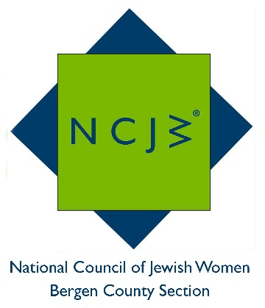
Bergenfield, NJ 07621

Contact:

Elizabeth Halverstam

ehalverstam@ncjwbcs.org

Ellen Ptalis Receives the Volunteer of the Month Award from the National Council of Jewish Women Bergen County Section

National Council of Jewish Women Bergen County Section (NCJW BCS) is proud to announce that Ellen Ptalis was awarded the November 2016 Volunteer of the Month Award. Ms. Ptalis has devoted herself to volunteering for the NCJW BCS and for programs they sponsor. At Youth Consultation Services (YCS) Holley Center, a residential treatment facility for emotionally and/or physically abused children in crisis, she co-chairs NCJW’s after-school arts and crafts program. At Bergen Family Center’s HIPPY program (Home Instruction for Parents of Preschool Youngsters) she teaches and plays with preschoolers while their parents learn to become their children’s first teachers. Ms. Ptalis volunteers her time at the NCJW BCS Thrift Shop, raising funds for the many programs sponsored by the organization. She is also involved with helping the Center for Food Action, helps with mailings and participates in a NCJW BCS book group.

Ms. Ptaslis has devoted her professional life to educating children. After earning her bachelor and master degrees from NYU and the University of Pennsylvania, she taught in the Bedford Stuyvesant neighborhood in Brooklyn. She and her husband then moved to Glen Rock, where they had two daughters and subsequently relocated in Hackensack. She returned to teaching, this time in the Bronx, and finding the commute onerous, became a mentor at Montclair University, from which she recently retired. She also helps with mailings and participates in a NCJW book group.
NCJW BCS provides educational and stimulating programs and speakers throughout the year, including six general meetings and a myriad of study groups, book groups and trips. For more information on NCJW BCS and its upcoming programs, please visit http://www.ncjwbcs.org.

The National Council of Jewish Women (NCJW) is a grassroots organization of volunteers and advocates who turn progressive ideals into action. Inspired by Jewish values, NCJW strives for social justice by improving the quality of life for women, children, and families and by safeguarding individual rights and freedoms

Photo Caption: Ellen Ptalis, who received the November Volunteer of the Month Award from National Council of Jewish Women.
