National Council of Jewish Women

Bergen County Section

75 South Washington Avenue

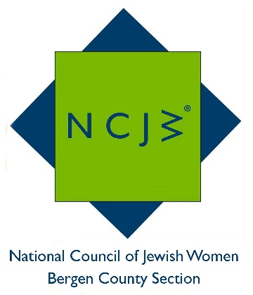
Bergenfield, NJ 07621

Contact:

Elizabeth Halverstam

ehalverstam@ncjwbcs.org

Founding of Holocaust Musicians’ Orchestra
Is Subject of NCJW General Meeting

TEANECK -- Josh Aronson, noted director and documentary filmmaker, will discuss a fascinating topic at the next General meeting of the National Council of Jewish Women Bergen County Section. The meeting will take place on Tuesday, May 16 at 12:30 PM at Temple Emeth, 1666 Windsor Road in Teaneck.

Mr. Aronson will discuss his famous film, Orchestra of Exiles, a story that took him all over the world to produce. The movie is about Bronislaw Huberman, the Polish violinist who founded the orchestra that would become the Israel Philharmonic. In creating this orchestra, Huberman arranged for the best Jewish musicians and their families to emigrate from Nazi-threatened territories. By doing this, he saved over one thousand Jews from almost certain death in the Holocaust. Mr. Aronson will tell us the story of Mr. Huberman’s dream to create this unique and lifesaving orchestra of exiles.

For audiences to gain a rich understanding of the topic, NCJW BCS will present a special screening of Orchestra of Exiles on Monday, May 8 at 2 PM at Temple Emeth. Though it is not necessary to see the movie to appreciate and enjoy Mr. Aronson’s talk, your understanding of the orchestra’s creation will be greatly enhanced by viewing it. There is no charge for the movie, which is approximately 90 minutes long.

Mr. Aronson began his career as a still photographer for Time Life Magazine and went on to direct many TV videos, pilots and specials before becoming a documentary filmmaker.

Jane Abraham, incoming Co-President of National Council of Jewish Women, says, “The story of the founding of the world-famous Israel Philharmonic Orchestra from Jewish musicians threatened by the Holocaust is a subject that will touch us all. We are very fortunate to have Josh Aronson as our next speaker.”
All are welcome to attend the meeting, which is free for members. There will be a $10.00 charge for non-members, payable at the door, which can be applied toward new membership if paid that day. NCJW BCS provides educational and stimulating programs and speakers throughout the year, including six general meetings and a myriad of study groups, book groups and trips. For more information on this meeting, or NCJW BCS and its upcoming programs, please contact office@ncjwbcs.org, call 201-385-4847 or visit http://www.ncjwbcs.org.

The National Council of Jewish Women (NCJW) is a grassroots organization of volunteers and advocates who turn progressive ideals into action. Inspired by Jewish values, NCJW strives for social justice by improving the quality of life for women, children, and families and by safeguarding individual rights and freedoms.

Photo caption:
Josh Aronson, noted director and documentary filmmaker, who will discuss Orchestra of Exiles, a film about Bronislaw Huberman, who created the Israel Philharmonic Orchestra by rescuing Jewish musicians from the Holocaust. Aronson will speak at the NCJW General Meeting on May 16 at 12:30 pm.

