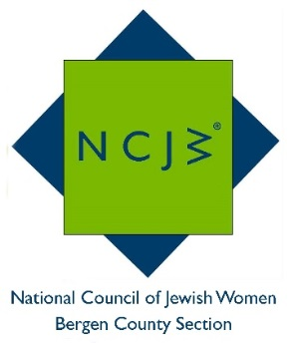
National Council of Jewish Women

Bergen County Section

75 South Washington Avenue

Bergenfield, NJ 07621

Contact:

Elizabeth Halverstam

ehalverstam@ncjwbcs.org

NATIONAL COUNCIL OF JEWISH WOMEN
SEPTEMBER 2016 VOLUNTEER OF THE MONTH

National Council of Jewish Women Bergen County Section is pleased to announce that Evelyn Masheb has been selected as its September Volunteer of the Month.

Ms. Masheb is a retired early childhood school teacher, reading specialist and staff developer. After retirement she was looking for a way to keep busy and found NCJW BCS. The rest is history! She volunteers at several of NCJW’s community services, including the Children’s Court Care Center at the Bergen County Courthouse (a supervised play area within the Courthouse for children of litigants involved in court proceedings) and organizes after-school activities for children at the YCS (Youth Consultation Service) Holley Center, a residential treatment home that offers a safe environment for children. In addition, she handles countless mailings of NCJW bulletins, newsletters, etc. at her home with a cadre of volunteers. She also helps out when needed at Bergen Family Center’s HIPPY program, which trains parents to be their children’s first teachers.

Evelyn is the mother of a daughter and a son and has four grandchildren.

NCJW is delighted to recognize Evelyn Masheb’s numerous and enthusiastic contributions to bettering the lives of children with this month’s Volunteer of the Month award. NCJW BCS provides educational and stimulating programs and speakers throughout the year, including six general meetings and a myriad of study groups, book groups and trips. For more information on NCJW BCS and its upcoming programs, please visit http://www.ncjwbcs.org.

The National Council of Jewish Women (NCJW) is a grassroots organization of volunteers and advocates who turn progressive ideals into action. Inspired by Jewish values, NCJW strives for social justice by improving the quality of life for women, children, and families and by safeguarding individual rights and freedoms.

Photo caption:
Evelyn Masheb with her NCJW Volunteer of the Month award
