National Council of Jewish Women

Bergen County Section

75 South Washington Avenue

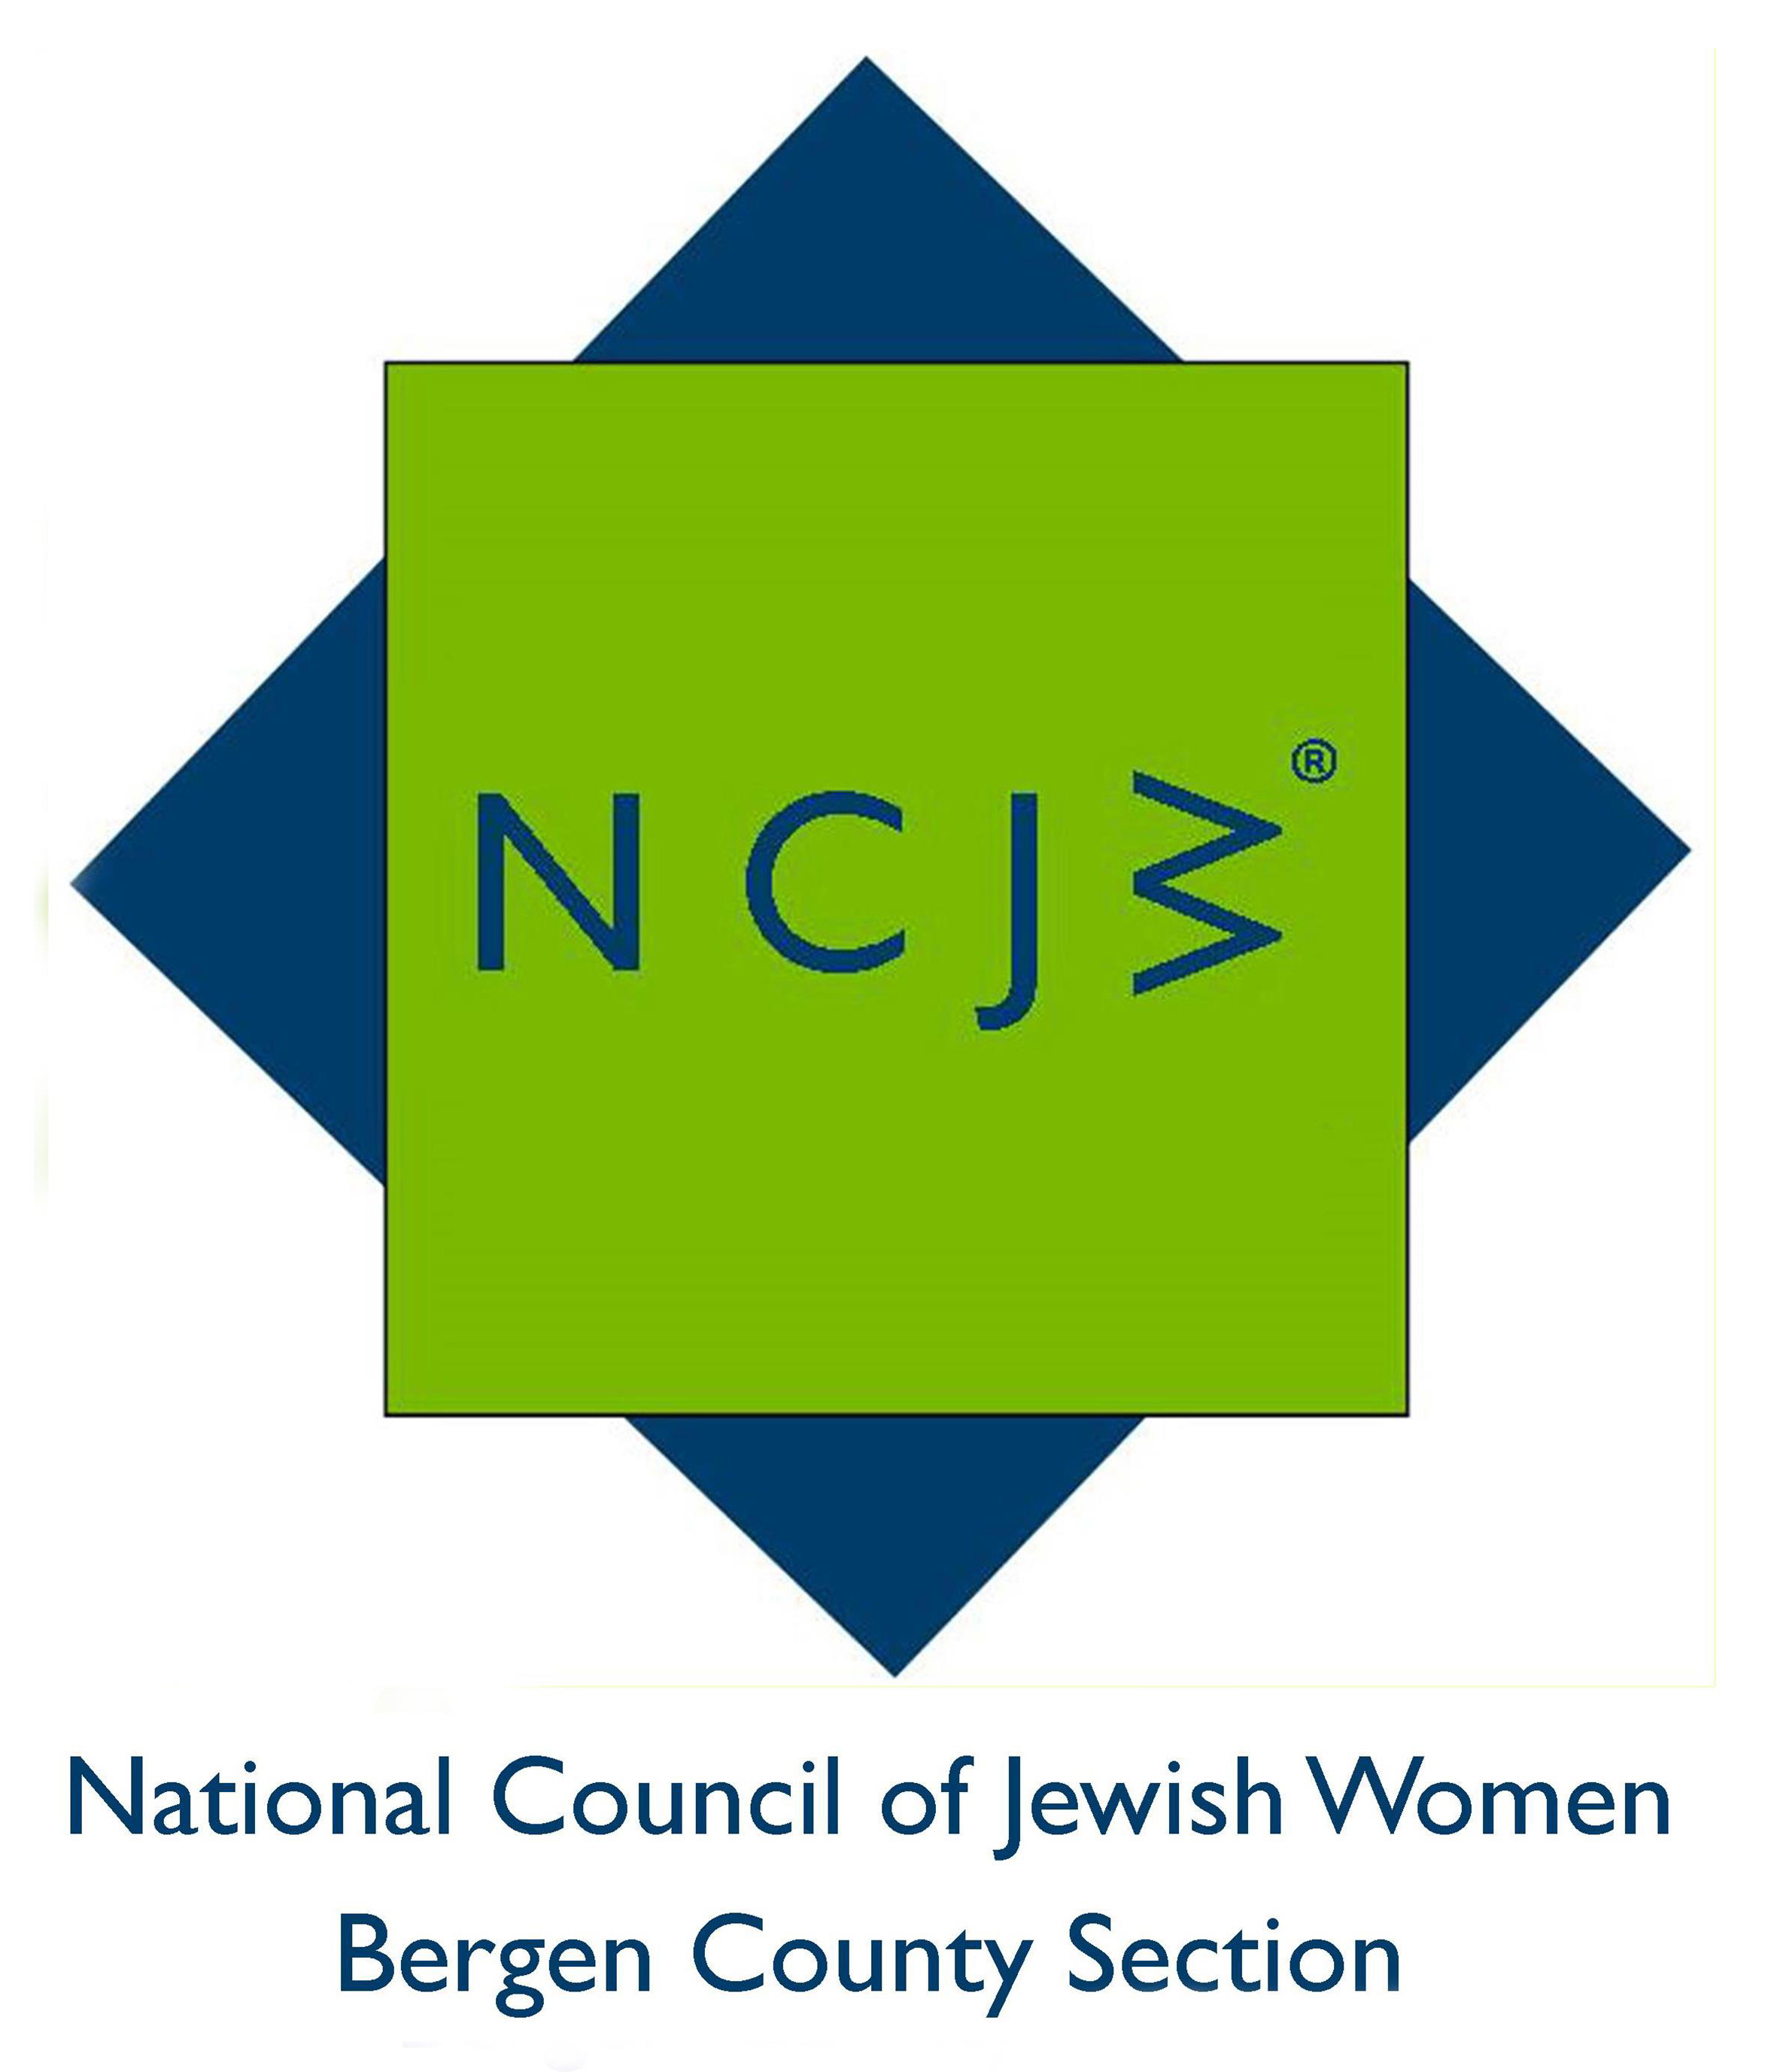
Bergenfield, NJ 07621

Contact:

Elizabeth Halverstam

ehalverstam@ncjwbcs.org

(201) 404-8816 – not for publication

AWARD-WINNNG AUTHOR TO SPEAK AT NCJW MEETING

TEANECK, NJ – Ariel Sabar, author of My Father’s Paradise: A Son’s Search for his Jewish Past in Kurdish Iraq, will be the speaker at the April General Meeting of the National Council of Jewish Women Bergen County Section (NCJW BCS). This debut book won the National Book Critics’ Circle Award for Autobiography, one of the highest honors in American letters. In his talk Mr. Sabar will weave the remarkable story of the Kurdish Jews and their Aramaic tongue with the moving tale of how a consummate California kid came to write a book about his family’s Kurdish roots.

The meeting will take place on Tuesday, April 19, 2016 at 12:30 pm, at Temple Emeth, 1666 Windsor Road, Teaneck, NJ, and light refreshments will be served. The event is free to members; a $10 charge for non-members, payable at the door, can be applied toward new membership if paid that day.

Growing up in materialistic 1980s Los Angeles, Mr. Sabar wanted nothing to do with his father. Yona Sabar was a distinguished professor at UCLA and one of the world’s foremost experts on Aramaic, the 3,000-year-old language of the Jewish Talmud — and of Jesus. But Ariel saw his father as a stone-age relic, a walking fashion tragedy who couldn’t get his clothes to match and refused to see a barber about his out-of-control, Einstein-like hair. Then Ariel had his own son, and everything changed.

Mr.Sabar’s second book, Heart of the City (2011), was called a "beguiling romp" (New York Times) and an "engaging, moving and lively read" (Toronto Star). His Kindle Single, The Outsider: The Life and Times of Roger Barker (2014), was a best-selling nonfiction short. He is also an award-winning journalist whose work has appeared in The New York Times Magazine, Harper’s, Washington Post, Mother Jones and This American Life, among many other places. He is a Smithsonian Magazine correspondent, a Washington Magazine contributing editor, and former staff writer for many publications. He graduated from Brown University and has lectured there as well as the University of Maryland-College Park, Johns Hopkins, George Washington University and Georgetown. He has been interviewed about his books and articles on NPR, PBS NewsHour, C-Span and the BBC World Service

“It will be fascinating to discover more about the history of a largely vanished people and the Jewish connection to Aramaic,” said Marilyn Sirulnick, NCJW’s General Meeting Program Coordinator.

NCJW BCS provides educational and stimulating programs and speakers throughout the year, including six general meetings and a myriad of study groups, book groups and trips. For more information on NCJW BCS and its upcoming programs, please visit http://www.ncjwbcs.org.

The National Council of Jewish Women (NCJW) is a grassroots organization of volunteers and advocates who turn progressive ideals into action. Inspired by Jewish values, NCJW strives for social justice by improving the quality of life for women, children, and families and by safeguarding individual rights and freedoms.

Photo caption
Ariel Sabar

