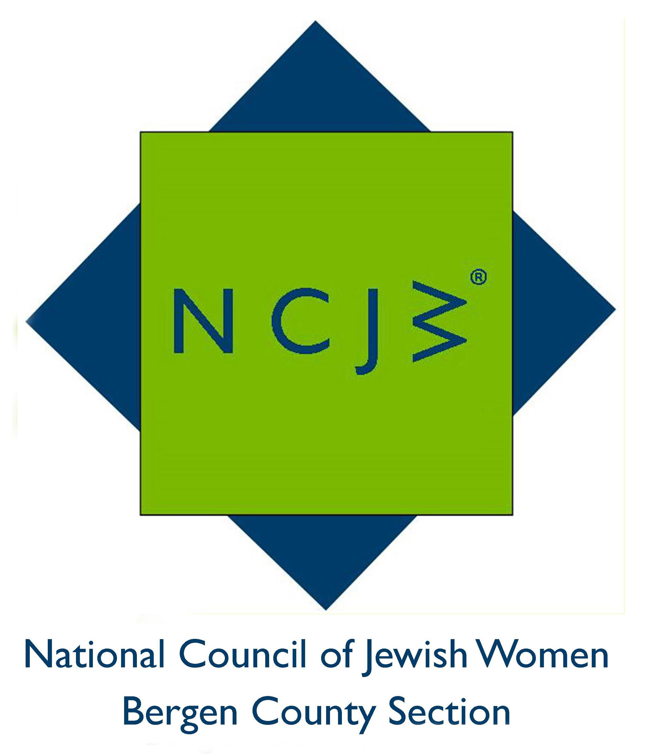

National Council of Jewish Women

Bergen County Section

75 South Washington Avenue

Bergenfield, NJ 07621

Contact:

Elizabeth Halverstam

ehalverstam@ncjwbcs.org

TEN NCJW MEMBERS PARTICIPATE
IN DOMESTIC VIOLENCE PREVENTION
HEALINGSPACE CLOTHESLINE PROJECT

HACKENSACK – Ten members of National Council of Jewish Women Bergen County Section recently participated in the YWCA Bergen County Healingspace Clothesline Project, an annual event that raises community awareness of violence against women, men, and children and demonstrates support for survivors. The Project provides an artistic way for women to express their feelings and to describe personal experiences of violence, which may otherwise be difficult for them to express. The event takes place outside the Hackensack Courthouse.
NCJW BCS is a long-time supporter of this project, now in its 20th year. Peggy Kabakow, a long-time member, proudly wore her t-shirt and silver pin from the 15th annual clothesline project. All were moved by the survivors’ messages on their t-shirts and the devastating impact of sexual assault on their lives. Some were angry; some were hopeful. All were part of the healing process.
Maureen Shaw read her inspiring essay Find Your Voice and Carry a Big Sign about her journey from overcoming sexual assault as a teen to becoming an outspoken activist, writer, and mother. New Jersey Senate Majority Leader Loretta Weinberg and Assemblywoman Valerie Vainieri Huttle, both NCJW life members and recipients of the Hannah G. Solomon award, emphasized the New Jersey legislative and policy advances to protect survivors of sexual assault and their hope that one day the need for this project would at least diminish, if not disappear.
Messages from the t-shirts created by the survivors of domestic violence were inspiring yet heart-rending. One wrote: “Some are angry, some are hopeful; all are part of the healing process.” Another t-shirt read: “A Child lost forever./No-one heard her cries./Alone, Scared, and Re-abused/I’ve found the courage to heal and survive.” And a third said, “No More Second Chances/Your Anger is NOT My Fault/Be Responsible for Your Actions/You Have NO Power over Me.”
NCJW BCS provides educational and stimulating programs and speakers throughout the year, including six general meetings and a myriad of study groups, book groups and trips. For more information on its programs, speakers and advocacy work, please contact office@ncjwbcs.org, call 201-385-4847 or visit http://www.ncjwbcs.org.

The National Council of Jewish Women (NCJW) is a grassroots organization of volunteers and advocates who turn progressive ideals into action. Inspired by Jewish values, NCJW strives for social justice by improving the quality of life for women, children, and families and by safeguarding individual rights and freedoms.

Photo captions:
Photo #5
Left to right: Christine Ordway and Helen Archontou, Board Member and CEO of the YWCA Bergen County, with NCJW members Sue Kanrich, Bari-Lynne Schwartz, Estelle Greene, and Ilene Wechter, at the YWCA Healingspace Clothesline Project
Photo # 3
T-shirts being hung at the YWCA Healingspace Clothesline Project.

