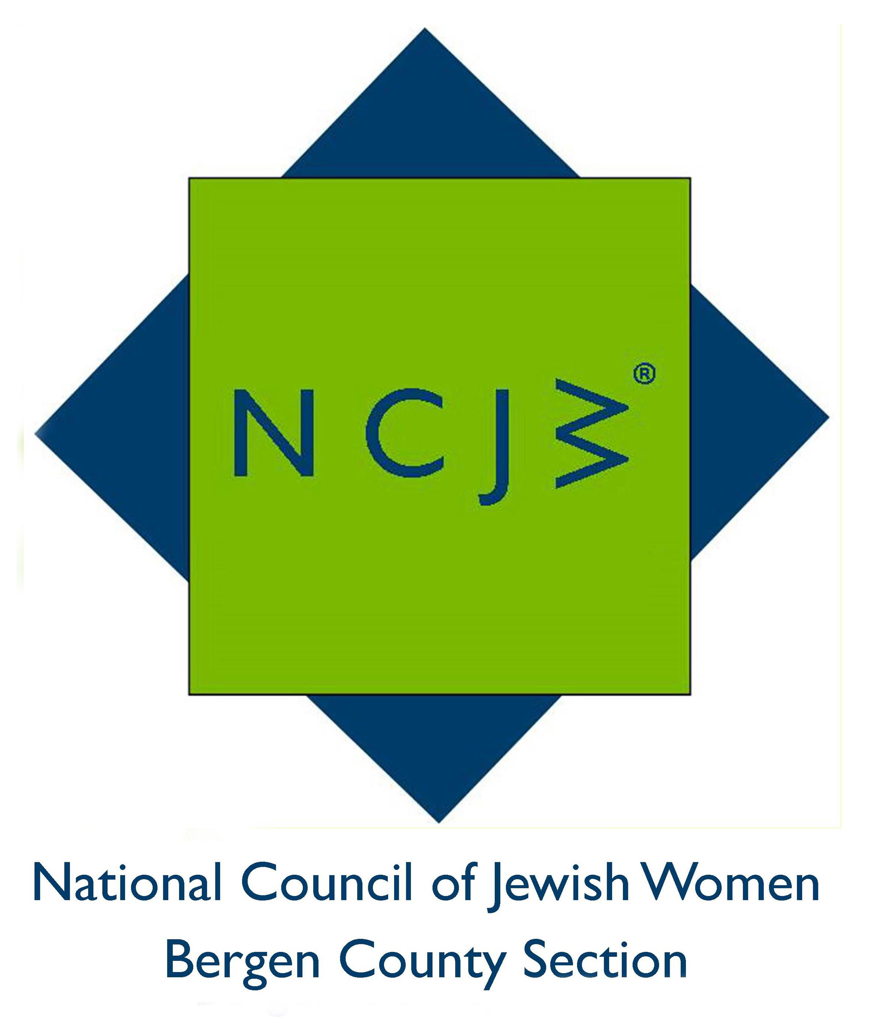
National Council of Jewish Women

Bergen County Section

75 South Washington Avenue

Bergenfield, NJ 07621

Contact:

Elizabeth Halverstam

ehalverstam@ncjwbcs.org

(201) 404-8816 – not for publication

THE AMERICAN JEWISH EXPERIENCE THROUGH CINEMA

National Council of Jewish Women Bergen County Section is delighted to welcome film critic Eric A. Goldman as the speaker at their upcoming General Meeting. Dr. Goldman will present a program entitled The American Jewish Experience through Cinema. The meeting will be held on Tuesday, March 15, 2016 at Temple Emeth, 1666 Windsor Road, Teaneck, commencing at 12:30 pm.

Dr. Goldman, a scholar on Israeli, Jewish and Yiddish film, is an engaging and informative lecturer who holds a Ph. D. in Cinema Studies from New York University and graduate degrees in Contemporary Jewish Studies and Theater Arts from Brandeis University. He is adjunct professor of cinema at Yeshiva University and film reviewer for New Jersey's The Jewish Standard.
A lecturer on Yiddish, Israeli and Jewish film and noted film educator and historian, Goldman is founder and president of Ergo Media, a distributor of Jewish-oriented cinema. He is former director of the Jewish Media Service, where he helped launch the concept of Jewish television programming and Jewish film festivals across North America. Prior to that, Dr. Goldman was curator of film for the YIVO Institute for Jewish Research, where he supervised the preservation of Yiddish films. He has developed and moderated film programs at a variety of institutions, including The Jewish Museum, The Center for Jewish History and the 92nd Street Y in New York City. Last September, he joined Robert Osborne on the Turner Classic Movies cable television network to co-host and program the five-week series, “The Projected Image: The Jewish Experience on Film.” Eric Goldman was also a member of the Educational Advisory Committee of the United States Holocaust Memorial Museum in Washington.

Having written extensively on the Jewish experience in film, Eric Goldman’s most recent book, “The American Jewish Story through Cinema,” about the American Jewish encounter with movies, was published in 2013 by University of Texas Press. His previous book was a history of Yiddish cinema. Currently he is working on a book about Israel through the lens of Israeli cinema. Last summer, he was made a fellow of the Schusterman Institute for Israel Studies. In June of 2015, Dr. Goldman was the curator of film for KulturFestNYC, an international Jewish Arts Festival in New York City. He has produced and directed for radio, television and film and has developed and authored over a dozen DVDs.

The meeting is free to members; there will be a $10 charge for non-members, payable at the door, which can be applied toward new membership if paid that day. Light refreshments will be served.

NCJW BCS provides educational and stimulating programs and speakers throughout the year, including seven general meetings and a myriad of study groups, book groups and trips. For more information on NCJW BCS and its upcoming programs, please visit http://www.ncjwbcs.org.

The National Council of Jewish Women (NCJW) is a grassroots organization of volunteers and advocates who turn progressive ideals into action. Inspired by Jewish values, NCJW strives for social justice by improving the quality of life for women, children, and families and by safeguarding individual rights and freedoms.

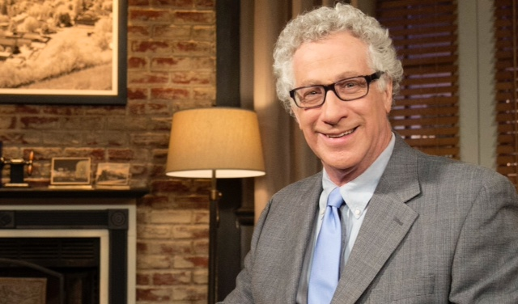
Photo caption:
Eric Goldman, PH.D., film critic of the Jewish Standard

