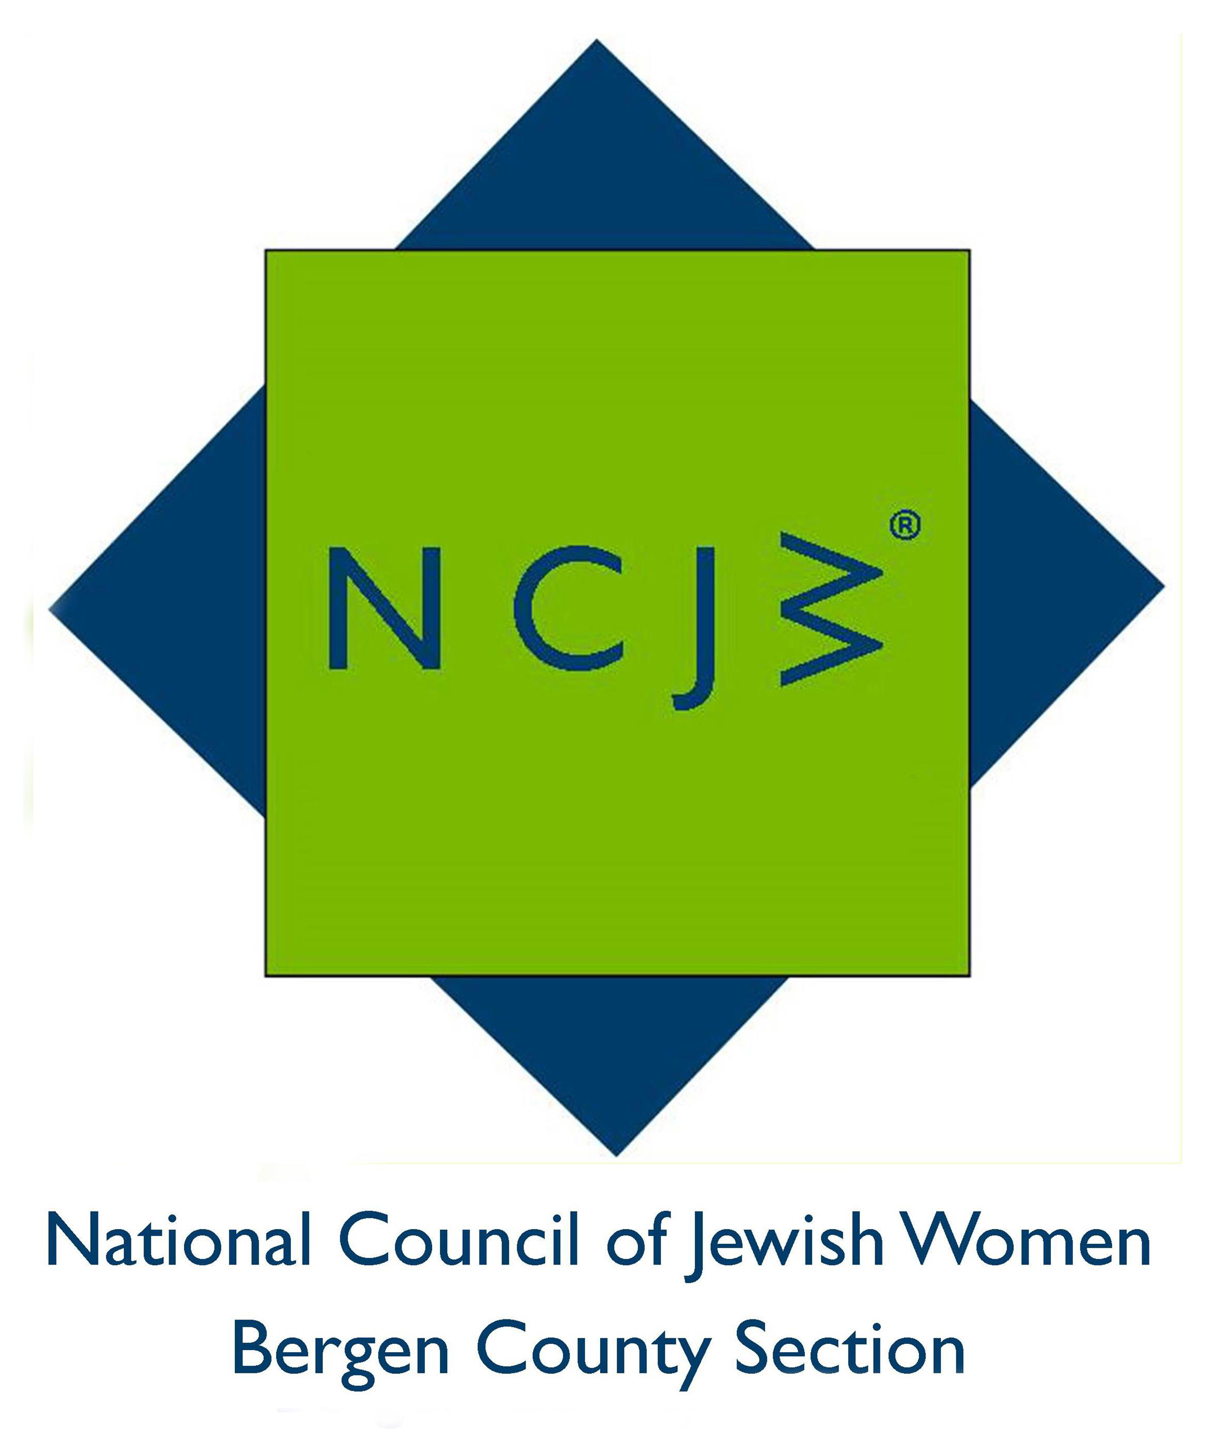

National Council of Jewish Women

Bergen County Section

75 South Washington Avenue

Bergenfield, NJ 07621

Contact:

Elizabeth Halverstam

ehalverstam@ncjwbcs.org

HIP HIP HOORAY FOR HIPPY

Excited children, proud parents, and delighted volunteers of the National Council of Jewish Women Bergen County Section celebrated the twenty-third annual HIPPY graduation held recently at Bergen Family Center. HIPPY, Home Instruction for Parents of Preschool Youngsters, is a national program that helps parents become their child's first teacher.

The strains of "Pomp and Circumstance" accompanied the children of HIPPY’s 2017 graduation class. Several students demonstrated their newly-developed literacy skills while parents praised the beneficial effects that the program had had on their children.

Clad in caps and gowns, the boys and girls accepted their certificates of accomplishment from Bergen Family Center CEO Mitch Schonfeld and Program Coordinator Rachel Ventrone, as proud parents and home instructors looked on.

National Council of Jewish Women Bergen County Section (NCJW BCS) co-founded HIPPY, a three-year pre-kindergarten program, with the Bergen Family Center in 1994. NCJW BCS volunteers provide assistance during monthly workshops, playing with the children while their parents attend a program.

The National Council of Jewish Women (NCJW) is a grassroots organization of volunteers and advocates who turn progressive ideals into action. Inspired by Jewish values, NCJW strives for social justice by improving the quality of life for women, children, and families and by safeguarding individual rights and freedoms.

Photo caption:
- National Council of Jewish Women volunteers look on with pride at the new graduates of Bergen Family Center’s HIPPY program.
- Students from Bergen Family Center’s HIPPY graduation. The HIPPY program is one of 16 community services supported by National Council of Jewish Women Bergen County Section.
