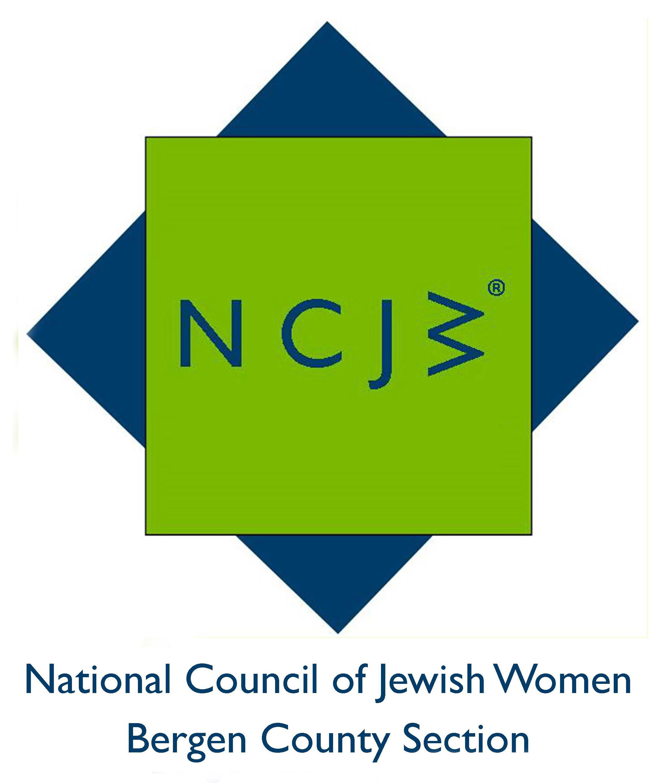

National Council of Jewish Women

Bergen County Section

75 South Washington Avenue

Bergenfield, NJ 07621

Contact:

Elizabeth Halverstam

ehalverstam@ncjwbcs.org

NCJW CELEBRATES INSTALLATION OF OFFICERS

TEANECK - National Council of Jewish Women Bergen County Section (NCJW BCS) held its 93rd annual installation and luncheon on June 7 at the Estate at Florentine Gardens in River Vale.

Installed for their second term as a Presidium were Fran Einiger of Hackensack, Marcia Levy of Englewood, Bea Podorefsky of Teaneck and Elaine Pollack of Bergenfield. Included in the installation were new officers Jane Abraham of Teaneck and Marilynn Friedman of Tenafly, who will serve as vice-presidents of Advocacy/Education, and Elizabeth Halverstam of Tenafly, who will be vice-president of Administration. The Board of Trustees included three new members: Bari Lynn Schwartz, Phyllis Grossman-Kaplan and Joan Ornstein.

In addition to installing the officers and Board of Trustees for 2016-2017, the members of NCJW honored Richard Mingoia, CEO of Youth Consultation Services (YCS) and members Evalyn Brownstein and Elizabeth Halverstam. Mr. Mingoia received the prestigious Hannah G. Solomon award in recognition of his work to provide care for over 7,000 children each day who need help. He was presented with a check in the amount of $4,000 to provide funding for medical equipment for the Holley Center Infirmary from the National Council of Jewish Women/Renee Guller bequest fund. BCS felt this was an appropriate way to remember a most generous woman.

Ms. Brownstein of Teaneck, who co-chairs NCJW BCS's HIPPY program (Home Instruction for Parents of Pre-School Youngsters) as well as the section Scholarship Committee, received the Woman of the Section Award for her many years of service to Bergen County Section. Ms. Halverstam was honored with the Emerging Leader Award.

State Senate Majority Leader Loretta Weinberg and Assemblywoman Valerie Vainieri Huttle, both of whom are NCJW life members, presented the awardees with Resolutions on behalf of the NJ State Senate and Assembly.

In addition, Estelle Greene, 96 years old, received a “surprise” Thrift Shop Volunteer Extraordinaire Award for her 55 years of service to the NCJW Thrift Shop.

NCJW BCS provides educational and stimulating programs and speakers throughout the year, including seven general meetings and a myriad of study groups, book groups and trips. For more information on NCJW BCS and its upcoming programs, please visit http://www.ncjwbcs.org.

The National Council of Jewish Women (NCJW) is a grassroots organization of volunteers and advocates who turn progressive ideals into action. Inspired by Jewish values, NCJW strives for social justice by improving the quality of life for women, children, and families and by safeguarding individual rights and freedoms.

Photo caption:
- Mingoia and Check.JPG: Richard Mingoia, CEO of YCS, with members of the NCJW Board
- Executive.JPG: National Council of Jewish Women Bergen County Section Executive Committee
- Evalyn & awards.JPG: Evalyn Brownstein receives NCJW’s Woman of the Section Award
- EG & LW.JPG: NJ Senate Majority Leader, and Elizabeth Halverstam, who received NCJW’s Emerging Leader Award

