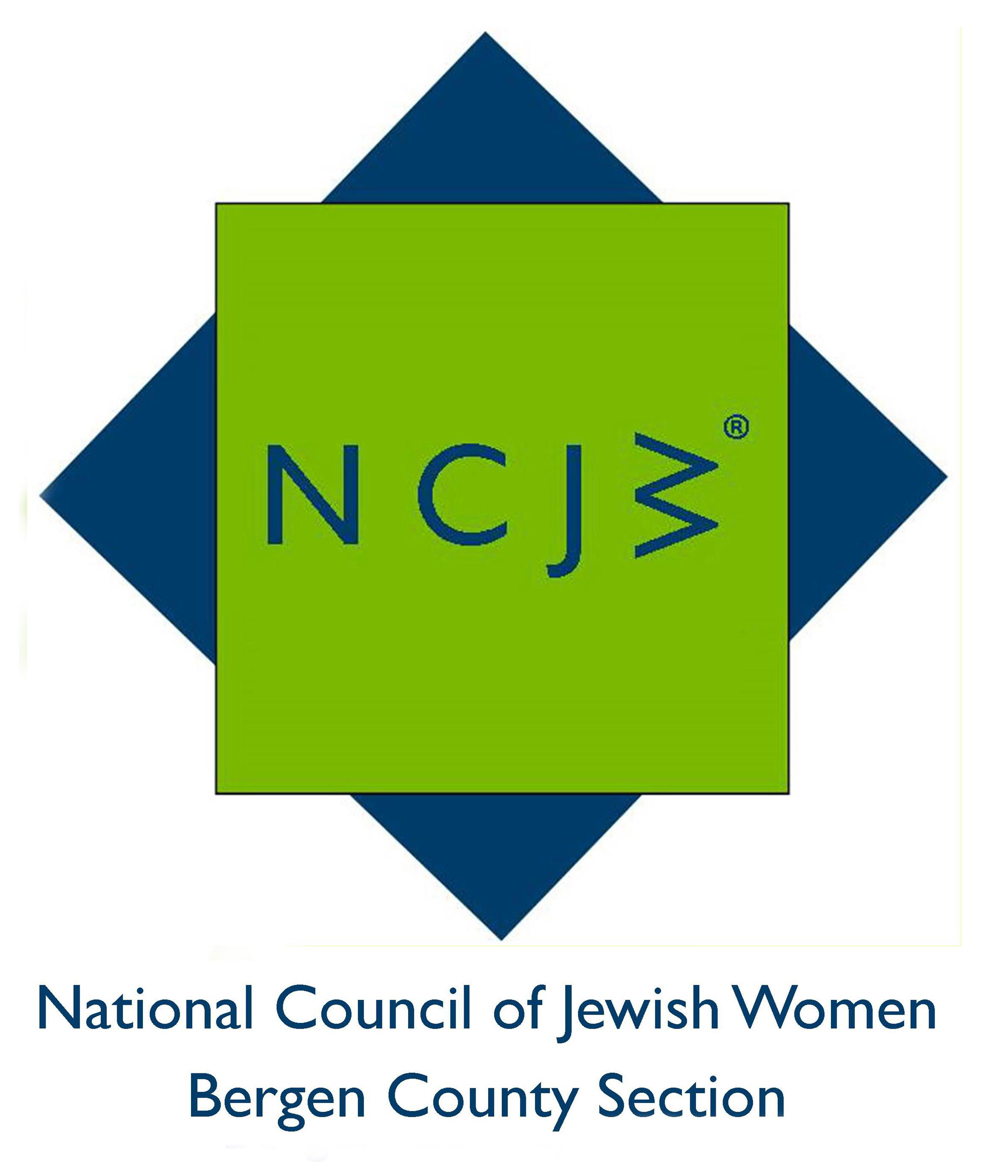

National Council of Jewish Women

Bergen County Section

75 South Washington Avenue

Bergenfield, NJ 07621

Contact:

Elizabeth Halverstam

ehalverstam@ncjwbcs.org

NCJW HELPS BRING ALL THE FUN OF THE FAIR TO jewish home residents
The National Council of Jewish Women Bergen County Section helped to make a special day for the residents of the Jewish Home at Rockleigh at their annual “Coney Island Day” on Monday, May22.
The ten NCJW volunteers ran the Carnival Games and helped the residents enjoy the event. The roulette and horse racing games were the residents’ favorites and everyone went away with prizes. “There will be a lot of happy grandkids,” said one resident, her arms filled with stuffed animals. She has 22 grandkids who will love them!
The National Council of Jewish Women (NCJW) is a grassroots organization of volunteers and advocates who turn progressive ideals into action. Inspired by Jewish values, NCJW strives for social justice by improving the quality of life for women, children, and families and by safeguarding individual rights and freedoms.

Caption
National Council of Jewish Women volunteers celebrate the start of the summer at “Coney Island Day” at the Jewish Home at Rockleigh.
