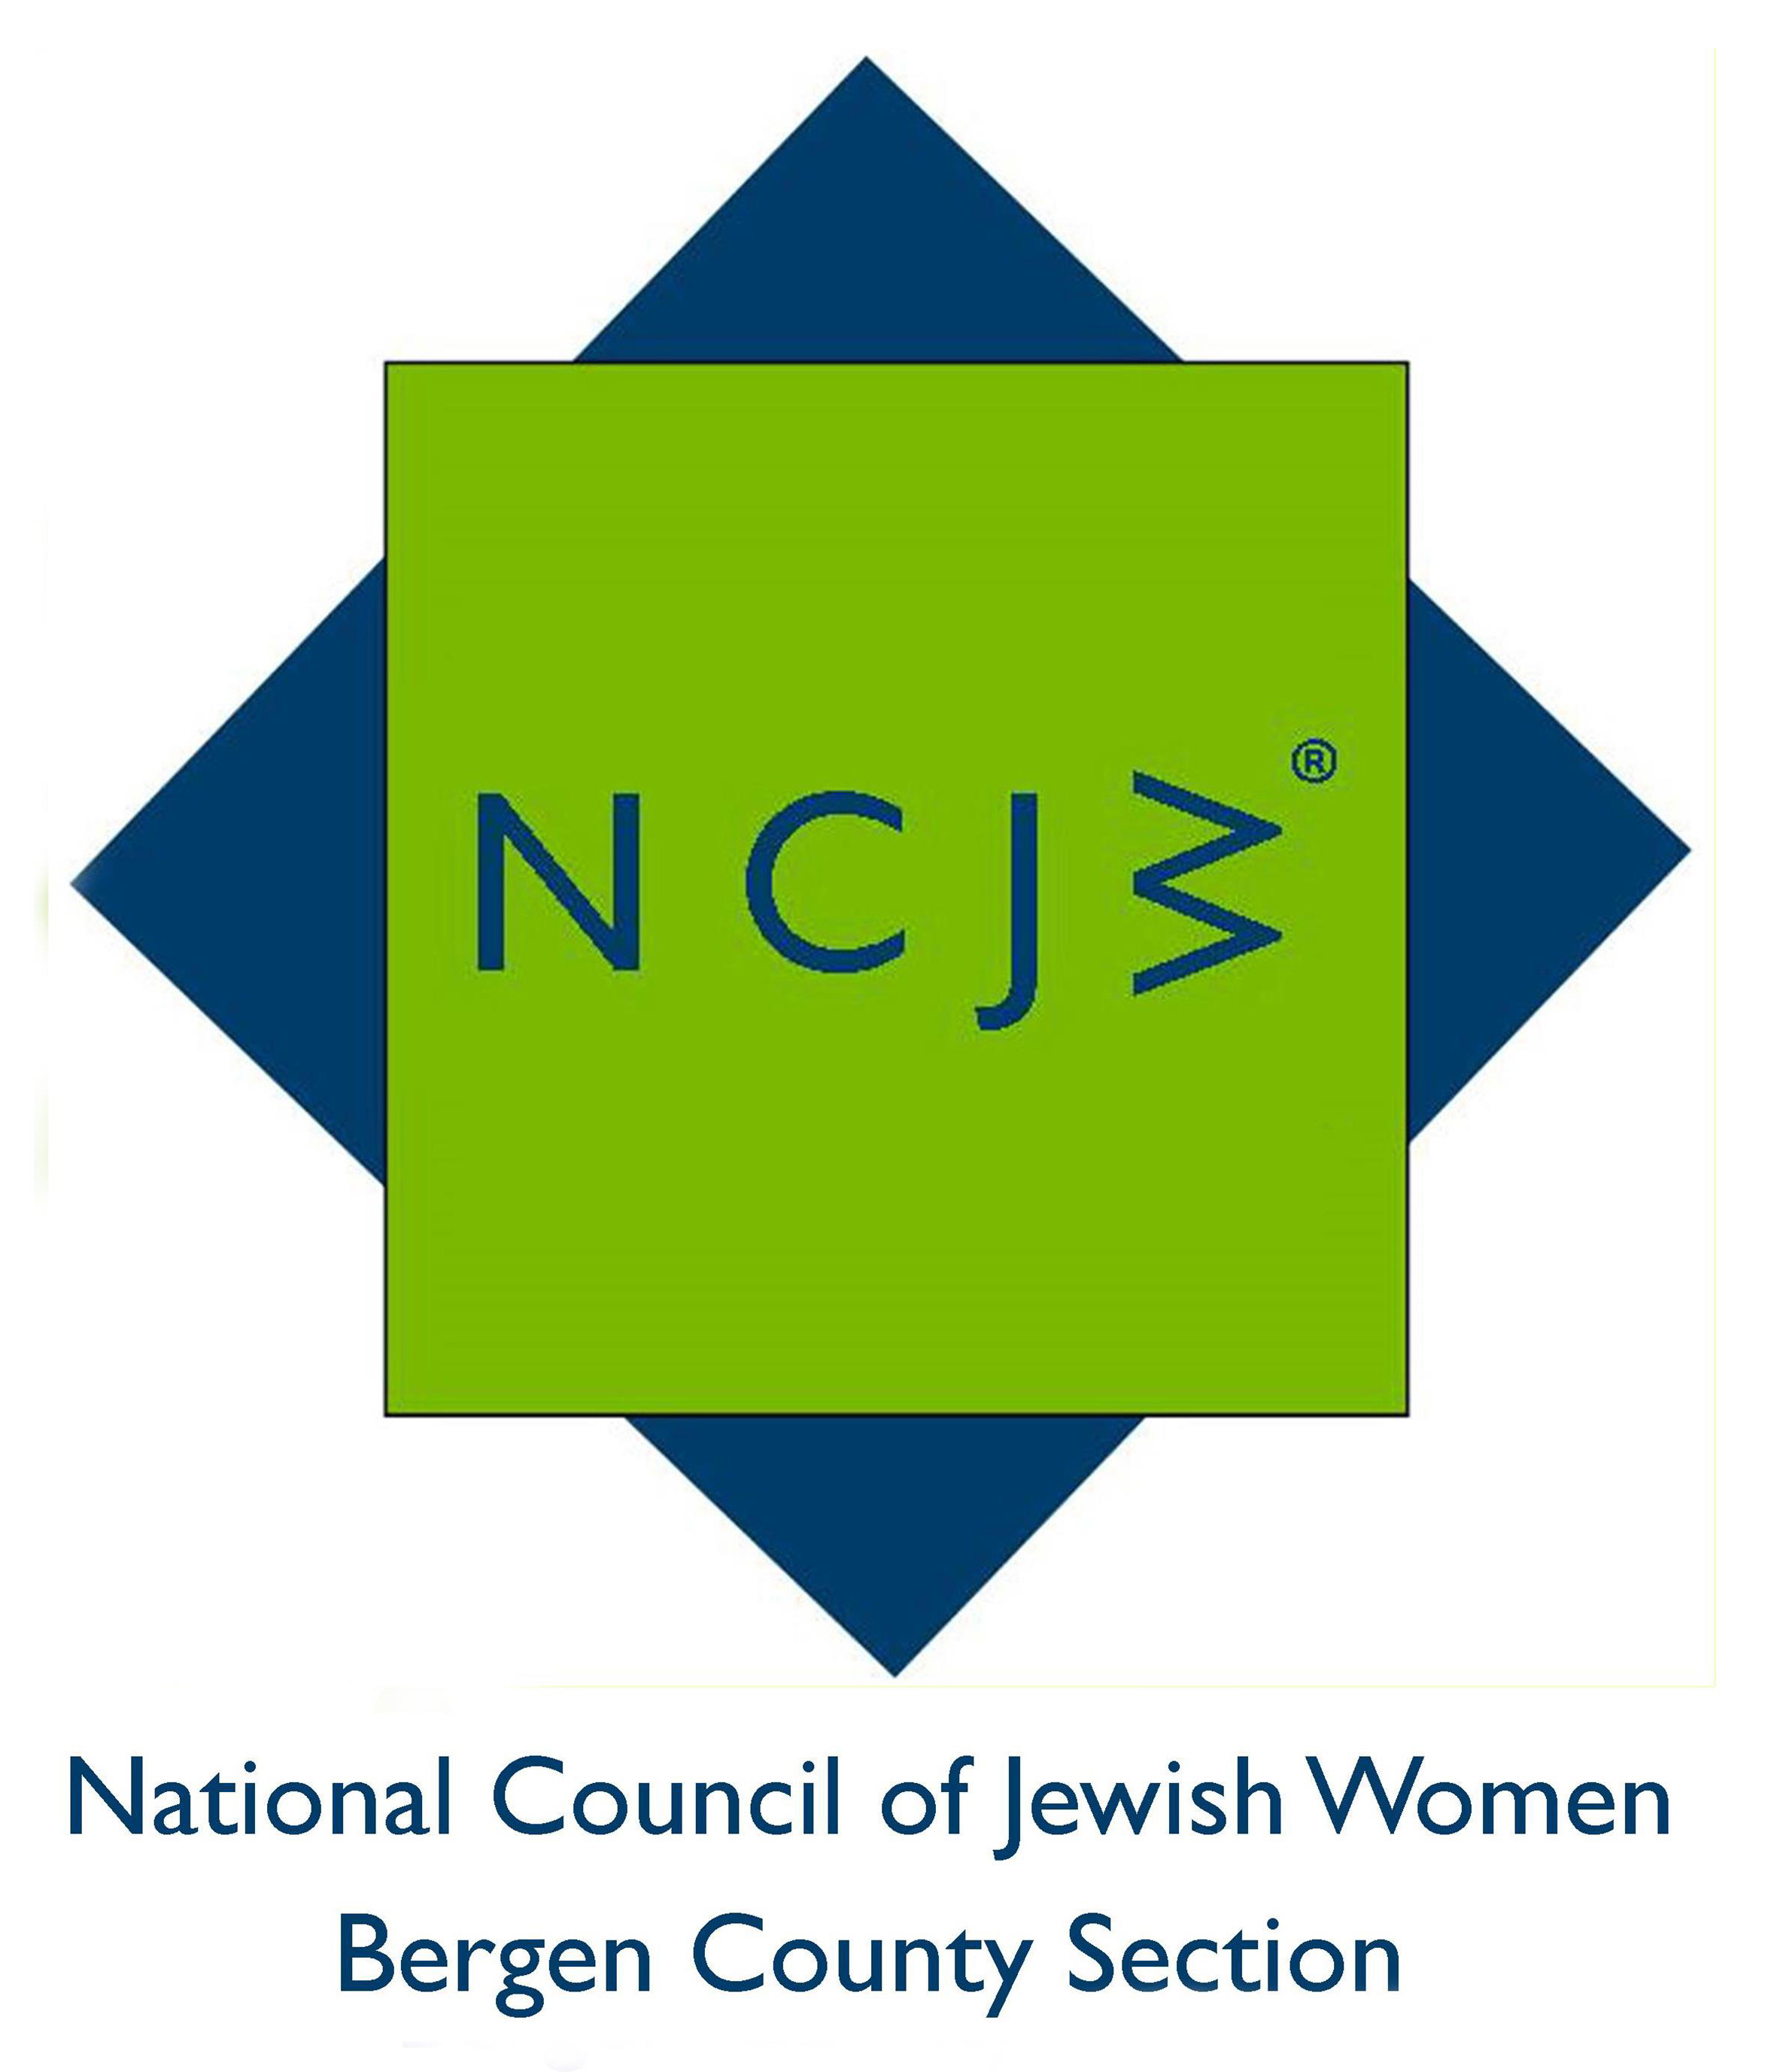

National Council of Jewish Women

Bergen County Section

75 South Washington Avenue

Bergenfield, NJ 07621

Contact:

Elizabeth Halverstam

ehalverstam@ncjwbcs.org

(201) 404-8816 – not for publication

ncjw honored at project s.a.r.a.h breakfast
National Council of Jewish Women Bergen County Section was proud to be one of the honorees at the Project S.A.R.A.H. 10th Annual Breakfast on Sunday, April 3, 2016.
Project S.A.R.A.H. (Stop Abusive Relationships at Home) is a program that works to overcome cultural, legal and religious barriers confronting victims of domestic violence and sexual abuse. While proudly serving the Orthodox Jewish community, Project S.A.R.A.H turns no-one away due to race, gender or financial difficulties.
Accepting the Volunteer Recognition Award on behalf of NCJW Bergen County Section, in the company of a large group of NCJW volunteers and supporters at Congregation Keter Torah in Teaneck, Marcia Levy, Presidium member, said, “We know that the home is a sacred place that needs to be protected with mutual respect and love by everyone who is a part of our community. We applaud Project S.A.R.A.H as it has expanded to educate children and parents to be aware of and meet the challenges of our changing society.”
NCJW’s National StoP initiative, Strategies to Prevent Domestic Violence, was created many years ago to further this concept. Since its founding in 1923, NCJW has stressed the importance that Jewish women place on recognizing the needs of their sisters. It is reassuring to know that Project S.A.R.A.H. exists to help those women and their families.
For more information on NCJW BCS, please visit http://www.ncjwbcs.org.

The National Council of Jewish Women (NCJW) is a grassroots organization of volunteers and advocates who turn progressive ideals into action. Inspired by Jewish values, NCJW strives for social justice by improving the quality of life for women, children, and families and by safeguarding individual rights and freedoms.

Photo caption:
- Marcia Levy, NCJW Presidium member, receiving award from Elke Stein, L.C.S.W., Project S.A.R.AH Consortium Director
- Marcia with award and New Jersey Proclamation

