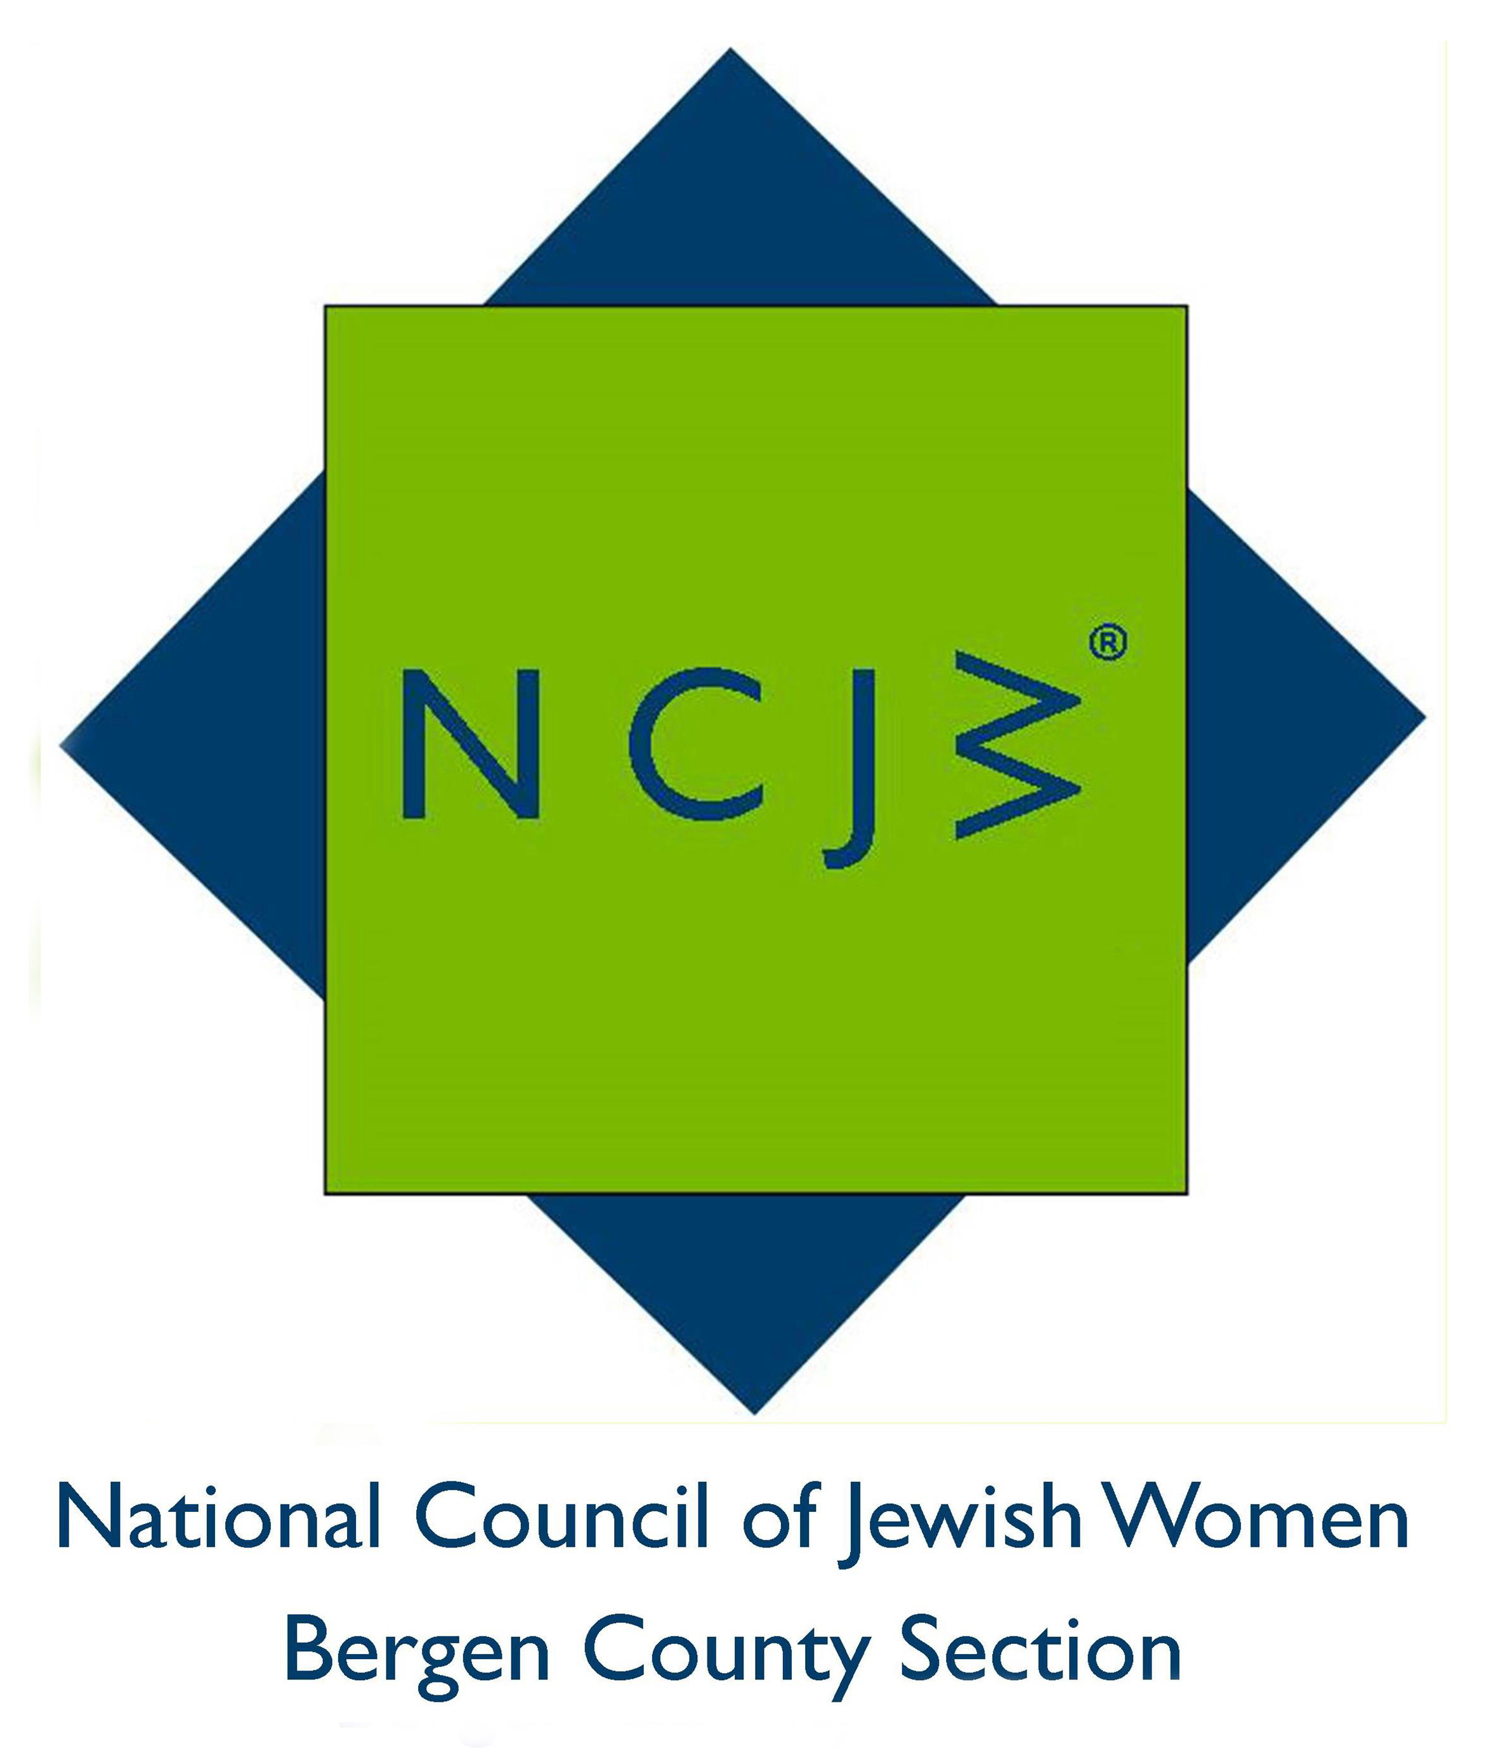

National Council of Jewish Women

Bergen County Section

75 South Washington Avenue

Bergenfield, NJ 07621

Contact:

Elizabeth Halverstam

ehalverstam@ncjwbcs.org

NCJW OFFERING SCHOLARSHIPS TO BERGEN COUNTY
JEWISH PUBLIC HIGH SCHOOL GIRLS
.
National Council of Jewish Women Bergen County Section is planning to award several $1000 endowed scholarships to young Jewish women who are graduating from Bergen County public high schools this year.
Among the criteria to be considered are the candidate's academic record, meaningful participation in school and/or community activities, and financial need.
Those who have been accepted into a four-year college or university may obtain further information and applications through their high school guidance office. The deadline for submission is April 15, 2016.
For more information on National Council of Jewish Women Bergen County Section, please visit http://www.ncjwbcs.org.

The National Council of Jewish Women (NCJW) is a grassroots organization of volunteers and advocates who turn progressive ideals into action. Inspired by Jewish values, NCJW strives for social justice by improving the quality of life for women, children, and families and by safeguarding individual rights and freedoms.

