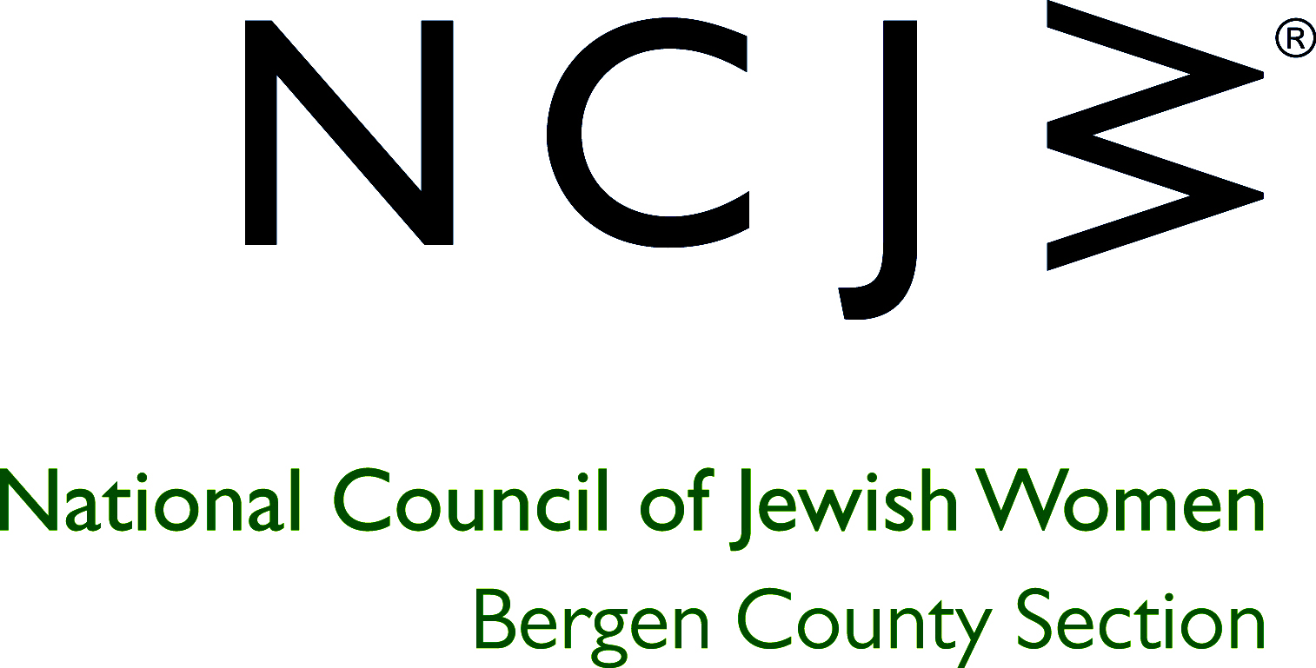

National Council of Jewish Women

Bergen County Section

75 South Washington Avenue

Bergenfield, NJ 07621

Contact:

Elizabeth Halverstam

ehalverstam@ncjwbcs.org

NCJW HOLDS ANNUAL LUNCHEON FOR SWIMMERS WITH MS

Once again members of the Swim-In Program, a National Council for Jewish Women Bergen County Section community service project for people with multiple sclerosis, met to spend a festive end-of-summer afternoon at the Tenafly Pizzeria Restaurant (TPR). Hugs and smiles were abundant as the dedicated volunteers and swimmers (individuals with multiple sclerosis) reunited to socialize, catch up with their friends, and enjoy a wonderful Italian meal.

Since 1976, NCJW BCS, in collaboration with the National MS Society NJ Metro Chapter, has provided a once-a-week water program where people with MS have an opportunity for therapeutic exercise. The social and exercise aspects of this unique community service are very rewarding to swimmers and volunteers alike and they will all be happy when Swim-In resumes on September 14th at the JCC on the Palisades in Tenafly.

The free therapeutic program runs at the JCC from September through May on Wednesdays from 1-3pm. The program is supervised by a licensed physical therapist. Volunteers assist clients in the locker room and with wheelchairs in the pool area. Each client is fitted with a buoyancy belt and helped into the pool where they swim or exercise with a trained volunteer. You do not need to know how to swim to volunteer and a short training program is provided. If you would like to volunteer for this unique program or for any other of NCJW’s 17 worthwhile community service opportunities, please email office@ncjwbcs.org, call 201-385-4847 or visit www.ncjwbcs.org.

The National Council of Jewish Women (NCJW) is a grassroots organization of volunteers and advocates who turn progressive ideals into action. Inspired by Jewish values, NCJW strives for social justice by improving the quality of life for women, children, and families and by safeguarding individual rights and freedoms.

Photo captions:
NCJW volunteers and swimmers (individuals with multiple sclerosis) enjoyed therapeutic exercise in the JCC pool and a delicious lunch at the Tenafly Pizzeria Restaurant (TPR).

